Meeting Coordinator

User Manual

Developed By:

John Booker, Jonathon Gower, and Thomas Morris

Table of Contents

Log In 3

Add a New Meeting to the Calendar 4

Delete Event 7

Edit Event 9

View Monthly Events 12

Conference Room Availability 14

Co-Ordinate Meetings 14

# Log In

1. When starting the meeting coordinator system, the user will be prompted to log in.

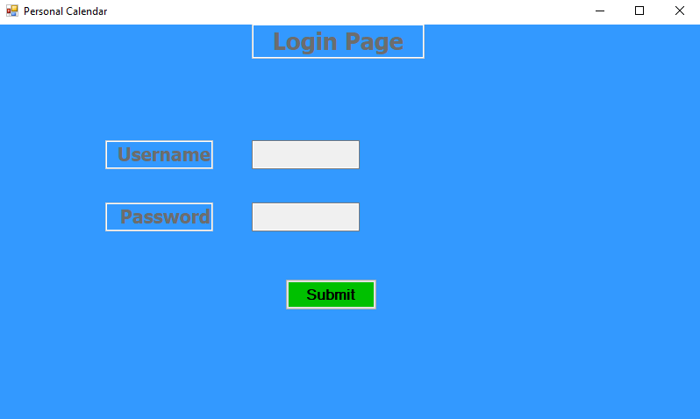

1. To log in, the user must enter their username and password that is provide to them by the company.

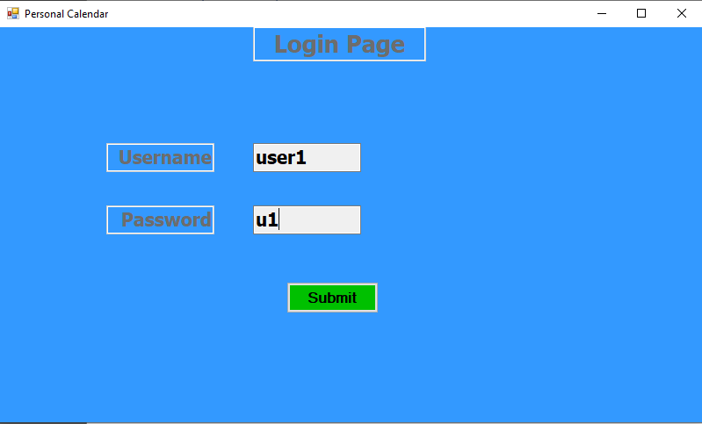

1. After entering their credentials, then the user must click the submit button. A successful login will show the personal calendar screen, otherwise the user show try their username and password again.
2. Default logins

|  |  |
| --- | --- |
| Username | Password |
| bossman | password |
| user1 | username1 |

# Add a New Meeting to the Calendar

1. Highlight the day of the meeting on the calendar.

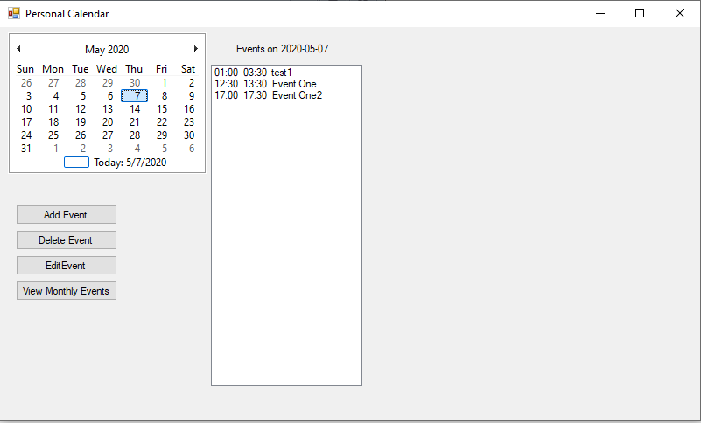

1. Press the “Add Event” or “Edit Event” button.

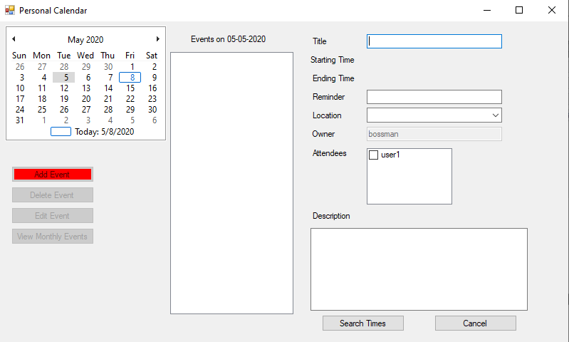

1. Fill out the form that appears on the right-hand side of the screen.
2. If you no longer want to add a new event, click the cancel button. Otherwise, click the “Search Times” button.
3. The system will display available starting times based on the information provided.

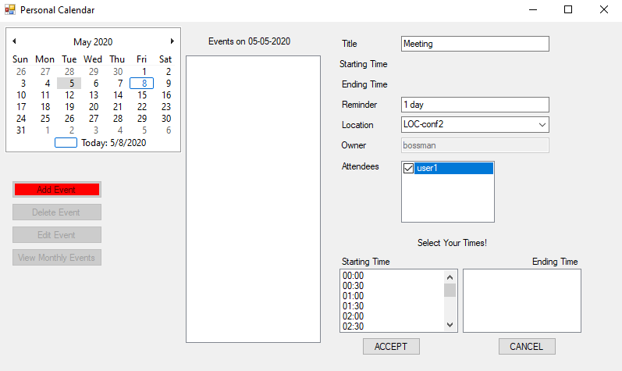

1. Select one of the available starting times.

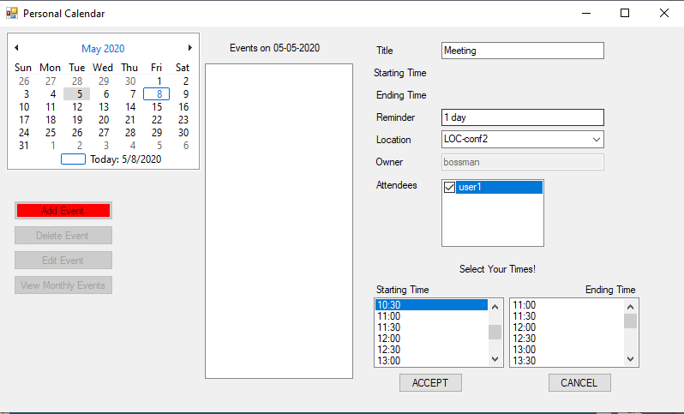

1. After selecting a starting time, the system will update with available ending times.
2. Select one of the provided ending times.
3. Select the “Accept” button to save the new event. Select the “Cancel” button to cancel.

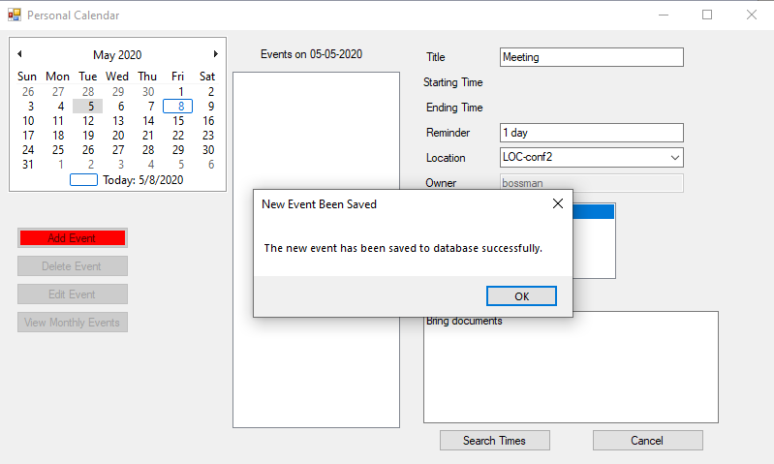

1. The system will display whether the new event has been saved successfully or whether it conflicts with an existing event. Press the “OK” button to close out of this dialog box. When there is a conflict, the user must update the event information to resolve the conflict in order to save.

# Delete Event

1. Select the date on the calendar that has the event to be deleted.
2. Select the event to be deleted.

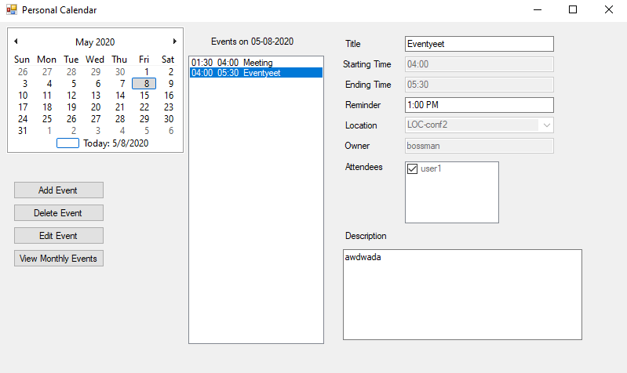

1. Select the “Delete Event” button. The logged in user must be the owner of the event to delete it. The following message will appear if you are not the owner of the event.

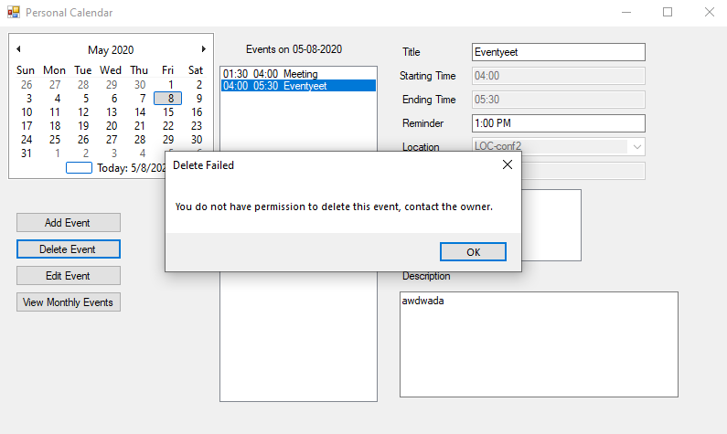

1. After selecting an event owned by the logged in user and pressing the “Delete Event” button a confirmation dialogue will appear.

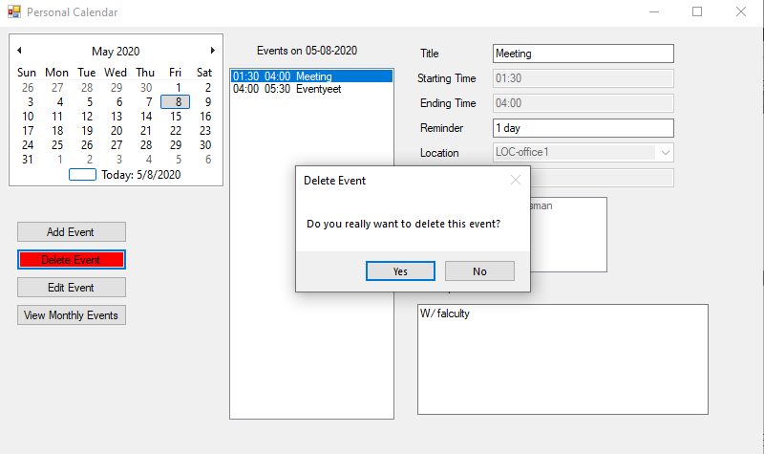

1. Select “Yes” to delete the event. Select “No” to cancel the deletion.
2. After selecting “Yes” the event will be removed from the owner and all attendee’s calendar.

# Edit Event

1. To edit an event the logged in user must be the owner of the event.
2. Select the date that has the event to be edited.
3. Select the event to be edit.
4. Select the “Edit Event” button.

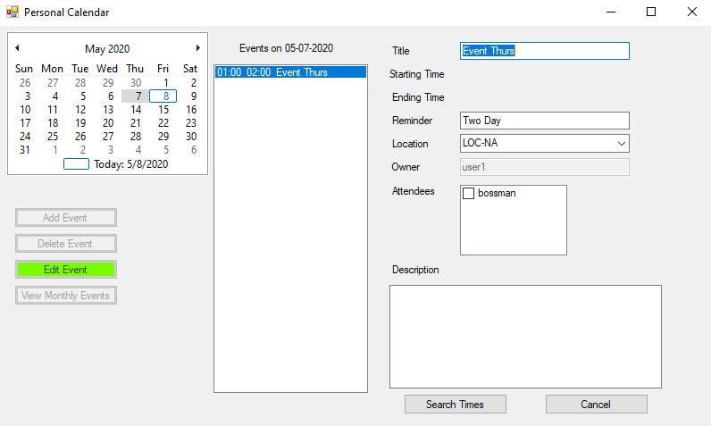

1. The event’s data will open up for editing.
2. Select the “Search Times” button.
3. The system will display the available start times for the event.
4. Select the desired start time.

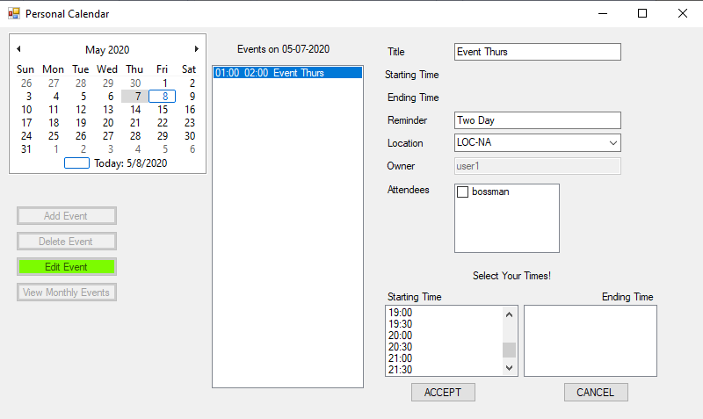

1. Select the desired end time.

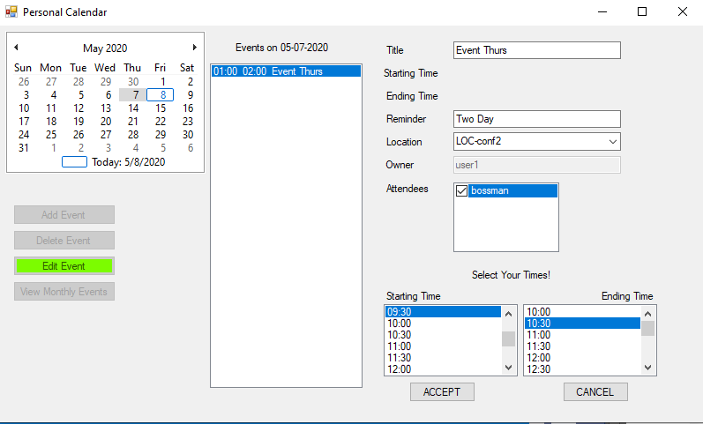

1. Select the “Accept” button to process the changes.
2. The system will display a confirmation when the event has been edited.

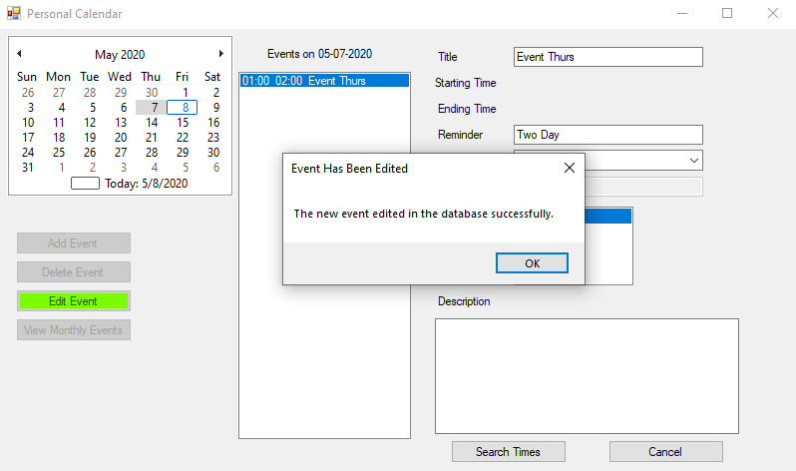

# View Monthly Events

1. Select a day from the month to view all events.

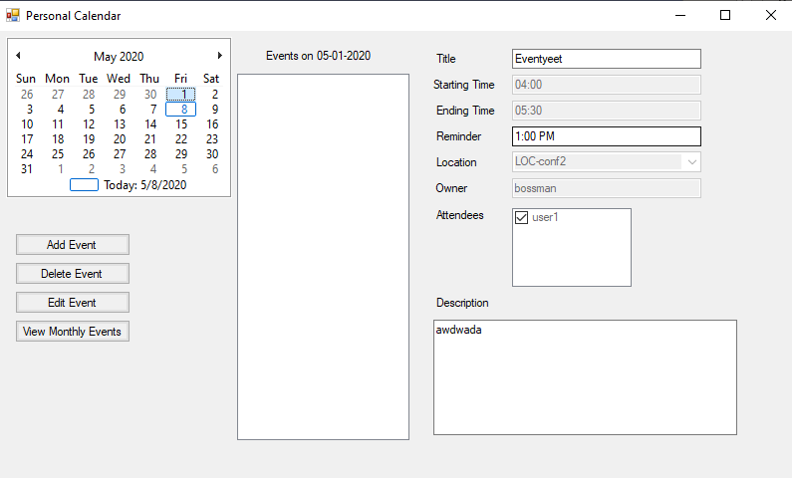

1. Select the “View Monthly Events” button.
2. The system will update will all events for that month.

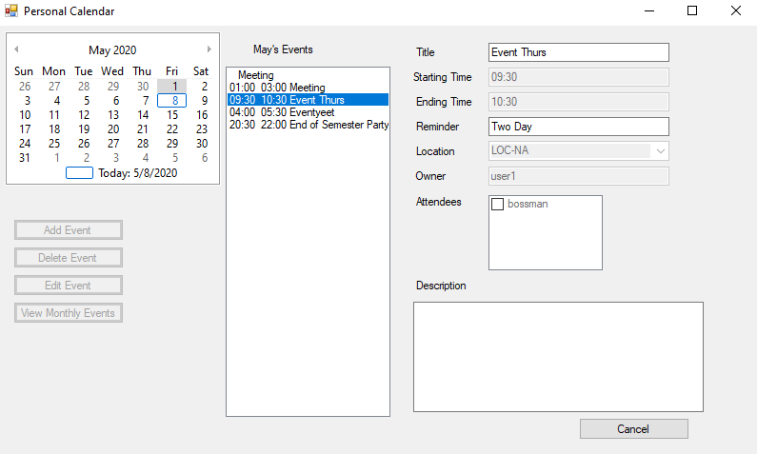

1. Select an event to view its details
2. Select the cancel button to return back to the events for today’s date.

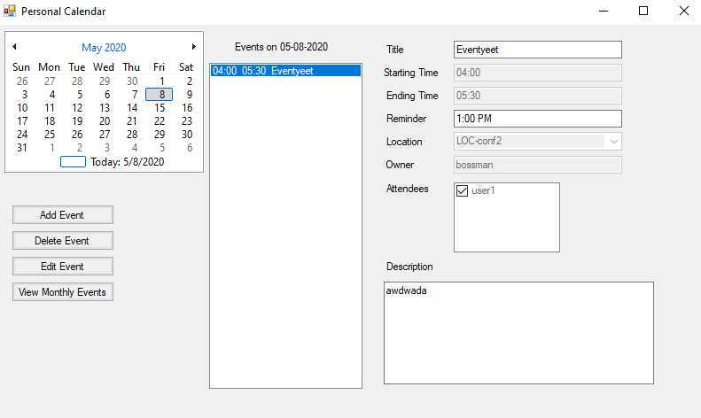

# Conference Room Availability

1. When adding or editing an event, the system automatically checks the availability of the selected room and provides valid starting and ending times.

# Co-Ordinate Meetings

1. When adding or editing an event, the system automatically checks the availability of the selected room as well as the availability of the attendees and provides valid starting and ending times.